**PharmEasy Assignment:**

<URL of the webapp>:<https://pharme.herokuapp.com>

GitHub Repository: <https://github.com/pranavlpin/pharmEasy/>

**Flow of the App:**

First page of the app (**<url>/** or **<url>/index.html**) is a login form for all the users, i.e. patients, doctors and pharmacists. Here user will login will be taken to their respective pages. Login details are there in the home page only.

**User Page:**

Here when user comes, he has the option to view all pending requests, and he can approve them as he likes.

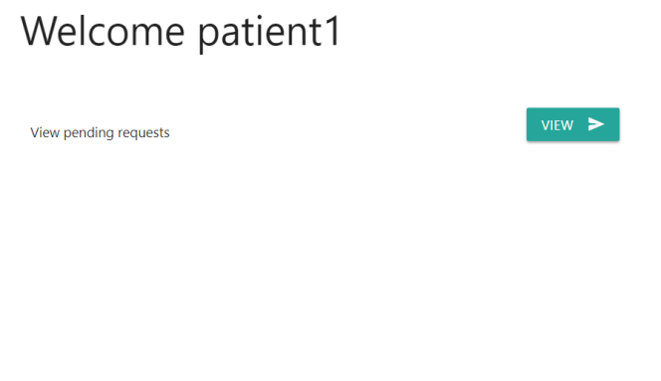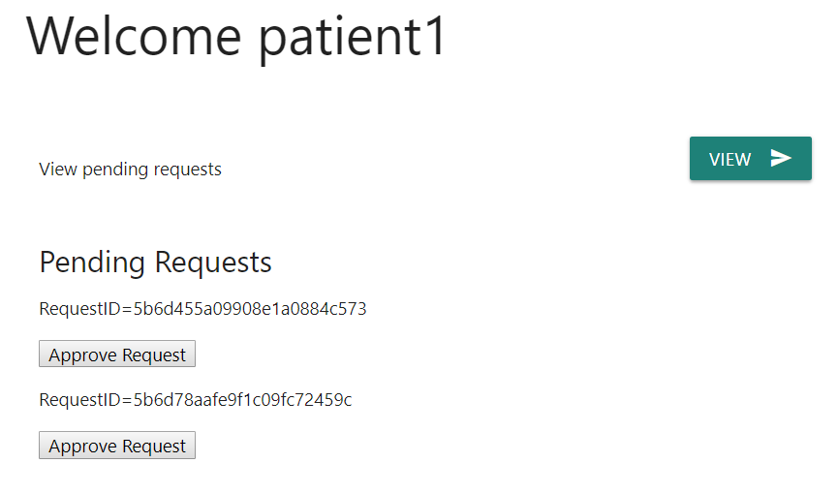

**Doctor Page:**

Here when doctor logins, he has an option to first view all patients.

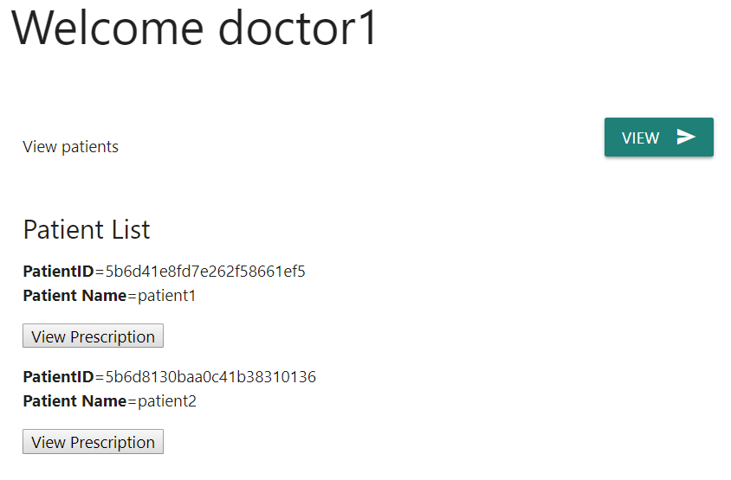

When the doctor clicks on View Prescription, if the user has already approved his existing request, then he will be able to view the prescription. Else he will get the message that user has not approved you request, and the doctor will have a button to send new request to the user.

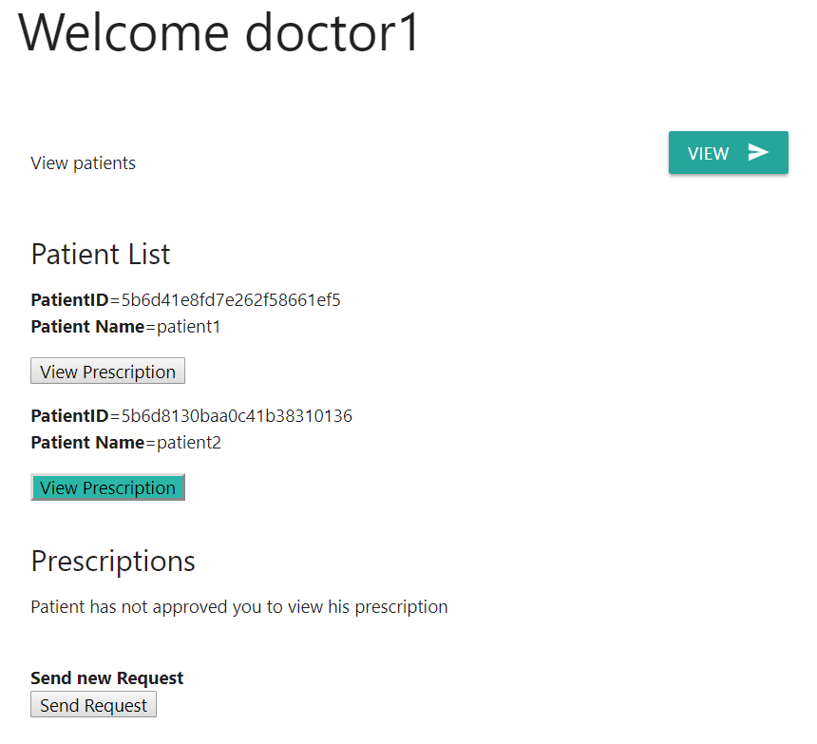

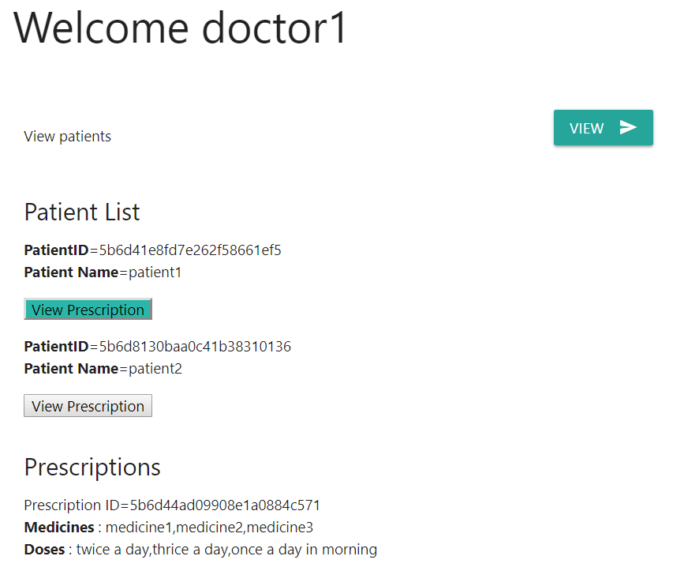

**Models:**

Models used along with their properties of each model are following:

**User:**

1. **username:** unique username of user
2. **password:** password of the user
3. **access:** access to identify if he is Doctor, patient or pharmacist

**Patient:**

1. **userId:** For authentication, linked to User model
2. **name**
3. **email**
4. **phone**
5. **address**
6. **age**
7. **gender**

**Doctor:**

1. **userId:** For authentication, linked to User model
2. **name**
3. **email**
4. **phone**
5. **address**
6. **age**
7. **gender**

**Pharmacist:**

1. **userId :** For authentication, linked to User model
2. **name**
3. **email**
4. **phone**
5. **address**
6. **age**
7. **gender**

**Prescription:**

1. **PatientId:** ID of the patient
2. **Medicines:** Name of medicines
3. **Doses:** Dose of medicine

**Request:**

1. **patientDetail:** ID of the patient
2. **doctorDetail:** ID of the doctor
3. **pharmacistDetail:** ID of the pharmacist
4. **requestApproved:** Binary: true if patient has approved request

**API Endpoints:**

**"<URL>/login":** API to login into APP

**"<URL>/users":** To **Get** all users and **Post** new user

**"<URL>/users/:user_id":** To **Get**, **Put**, **Post** a particular user

**"<URL>/doctors":** To **Get** all doctors and **Post** new doctor

**"<URL>/doctors/:doctor_id": Get**, **Put**, **Post** a particular Doctor

**"<URL>/pharmacists":** To **Get** all pharmacists and **Post** new Pharmacist

**"<URL>/pharmacists/:pharmacist_id": Get**, **Put**, **Post** a particular Pharmacist

**"<URL>/patients":** To **Get** all Patients and **Post** new Patient

**"<URL>/patients/:patient_id": Get**, **Put**, **Post** a particular Patient

**"<URL>/prescriptions":** To **Get** all Prescriptions and **Post** new Prescription

**"<URL>/prescriptions/:prescription_id": Get**, **Put**, **Post** a particular prescription

**"<URL>/requests": Get** all Requests and **Post** new Request

**"<URL>/requests/:request_id": Get**, **Put**, **Post** a particular Approval request

**"<URL>/doctorPatientRequest": Post** request to get requests from a particular doctor to the particular patient

**"<URL>/pharmacistPatientRequest": Post** request to get requests from a particular pharmacist to the particular patient

**"<URL>/patientRequests": Post** request to get all approval requests sent to the particular patient

**"<URL>/patientPrescriptions": Post** request to get prescriptions of the particular patient